Grid Intelligence Platform (GIP): Trainging
Project: Autonomous system for orchestration, monitoring and control of electrical networks using hybrid AI models and cognitive dispatch. (see /Users/mikin/qualco/GIP_Models/doc/Ollama_GIP_KONCEPČNÍ REPORT.docx

Overview
This document relates to the component #4. ,Cognitive LLM Orchestrator shown on the figure 1. It describes the training approaches and sequences from high level perspective.
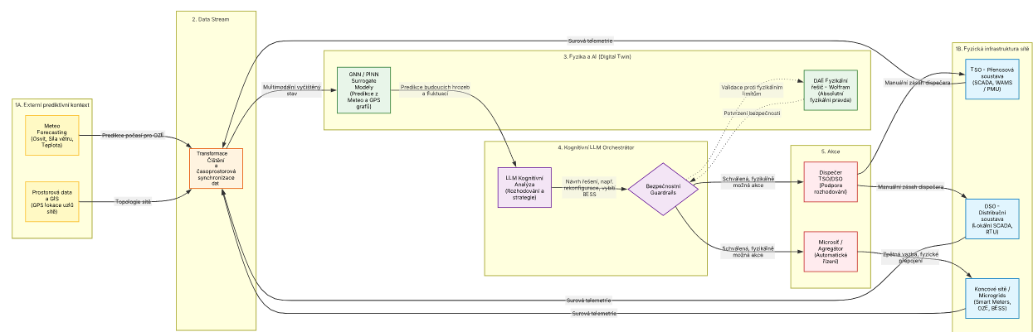Figure 1: Architecture

Steps:
- Simulated training on the python generated grid node using python torch neural net model – prove of concept.
  - Uses wolfram math models
  - No link to any LLM cognitive core
  - Manual training data entry
  - Web visualization using python streamlit
- Grid model configured using a real electrical grid configuration of a small node that is maintained by python pandpower.networks module
  - Same points as 1.1 and 1.2 apply here
  - Data entry from generated random simulated sensors within physical limits
  - The goal is to observe responses within physical limits that lead to the grid staying within desirable stability parameters.
- Grid model configured using a real electrical grid configuration of a small node that is maintained by python pandpower.networks module
  - Same points as 1.1 apply here
  - The neural network maintained by python is linked to the LLM cognitive core (referred as “core model” through this document) provided by a chosen vendor (i.e DeepSeek, Anthropic, OpenAI, etc.)
    - Alternatively we can “copy” the parameters of the core model into the initial python torch net and train it as a whole is that give better result.
      - For this we would need an access to the core model database
      - The core model license needs to allow for that.
      - To my knowledge the only core model matching the above 2 criteria is, at the time of writing, the DeepSeek one since it’s an open source.
  - Data training batches from the above point 2.2 are combined with the real past recorded data from sensors of the given grid node configuration.
  - Both data is filtered by the component #2 shown on the figure 1.
  - The goal is the same as depicted by the point 2.3 above.
  - The resulting trained neural net becomes an “envelope” for the LLM cognitive core mentioned in the point 3.2 above.
- Same setup, procedure and the final goal as described by the above point 3. while adding climate data / weather reports.

